Screen Designs
Created on 12/08/2012
Table of Contents
SketchFlow Map 1
Navigation Screens 1
Main 2
About 2
Add Subject 2
Add Task 3
Add Task Wizard 3
Add Task Wizard 2 4
Edit Task 4
Figures
Figure 1: SketchFlow Map 1
Figure 2: Main 2
Figure 3: About 2
Figure 4: Add Subject 2
Figure 5: Add Task 3
Figure 6: Add Task Wizard 3
Figure 7: Add Task Wizard 2 4
Figure 8: Edit Task 4

SketchFlow Map
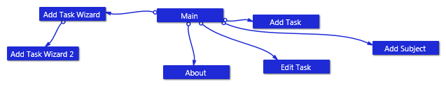
Figure 1: SketchFlow Map

Navigation Screens

Main
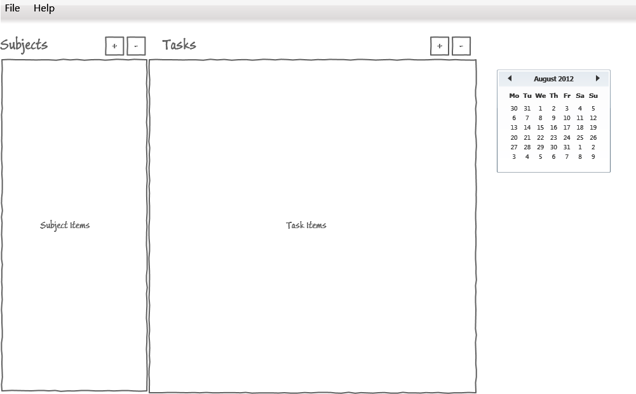
Figure 2: Main

About
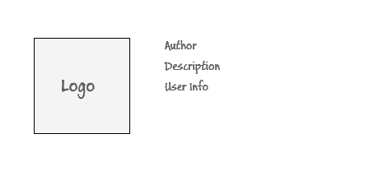
Figure 3: About

Add Subject
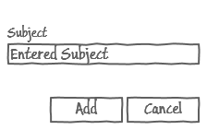
Figure 4: Add Subject

Add Task
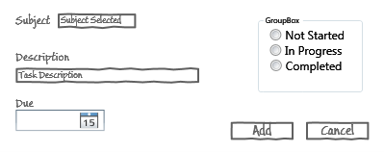
Figure 5: Add Task

Add Task Wizard
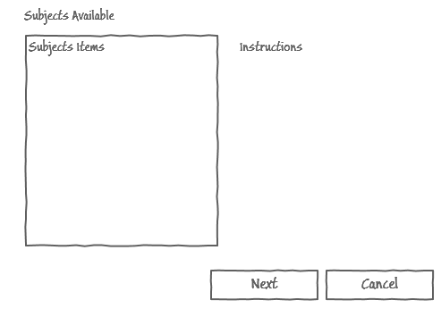
Figure 6: Add Task Wizard

Add Task Wizard 2
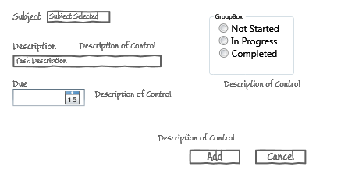
Figure 7: Add Task Wizard 2

Edit Task
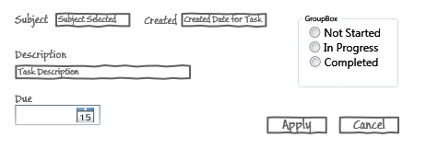
Figure 8: Edit Task

